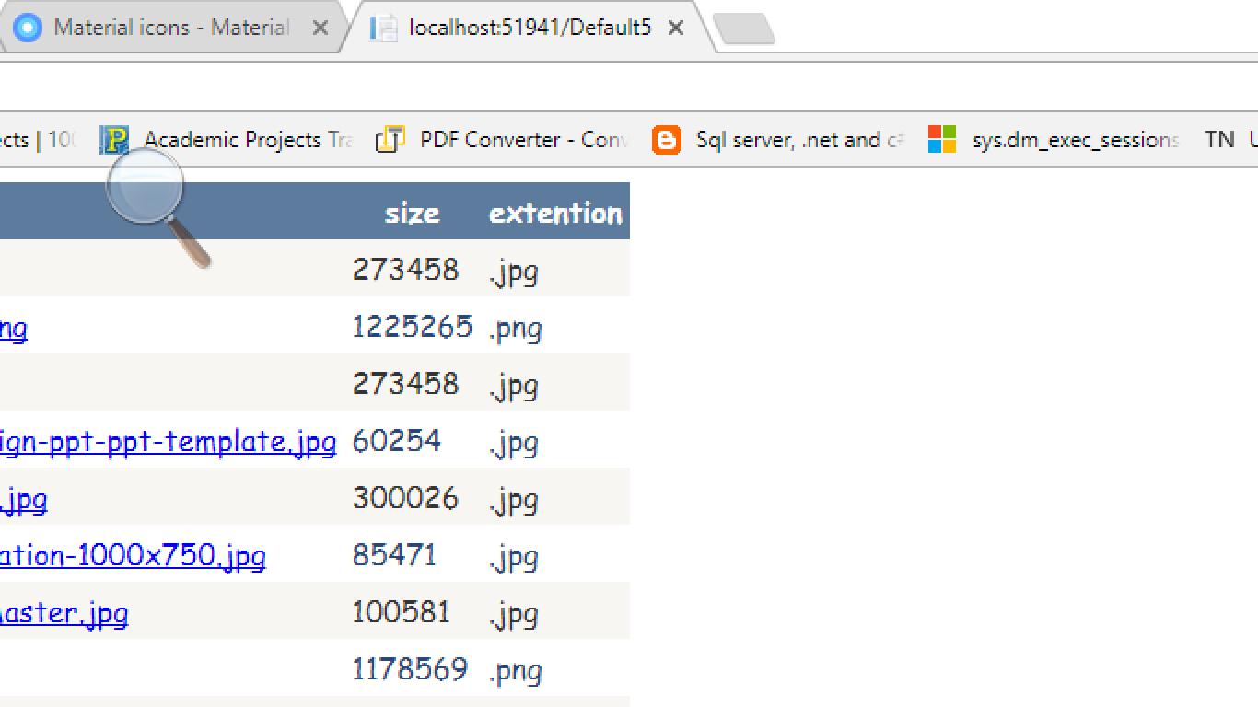

By default icon

<link rel="shortcut icon" href="~/favicon.ico" type="image/x-icon"/>

Runs only in local iss server

Favicon.com to download favourite icon.

Called FAVOURITE ICON

